**BTW ML/DL Report**

**Installing Git:**

I have Installed Git using the link that given in instruction and also use d command to check if it is installed or not.

**i.e git version**

**Connecting Git to Github:**

In order to connect git to github I have use following commands:

**Verifying username**

**git config --global user.name "Name"**

**git config --global user.name (in order to check)**

**Verifying email**

**git config --global user.email "email"**

**git config --global user.email (in order to check)**

**Git Commands:**

**git commit:**

Records changes to the repository with a message describing the changes: git commit -m message. Saves a snapshot of the staged changes to the project’s history.

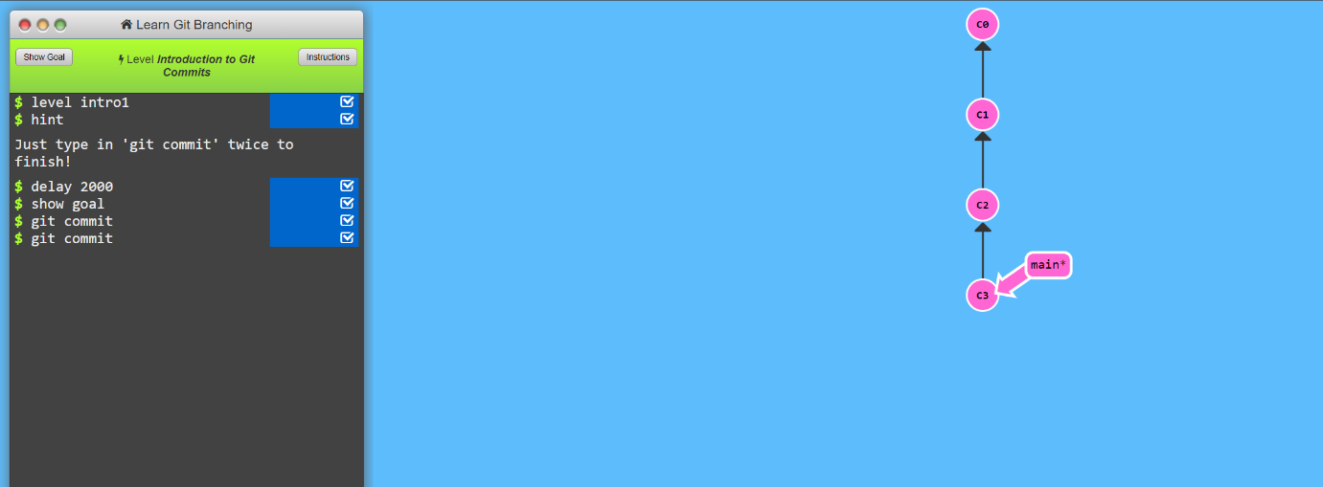

**git branch:**

Creates and manages branches: git branch branch_name, git checkout branch_name. Allows you to work on different features or fixes without affecting the main branch.

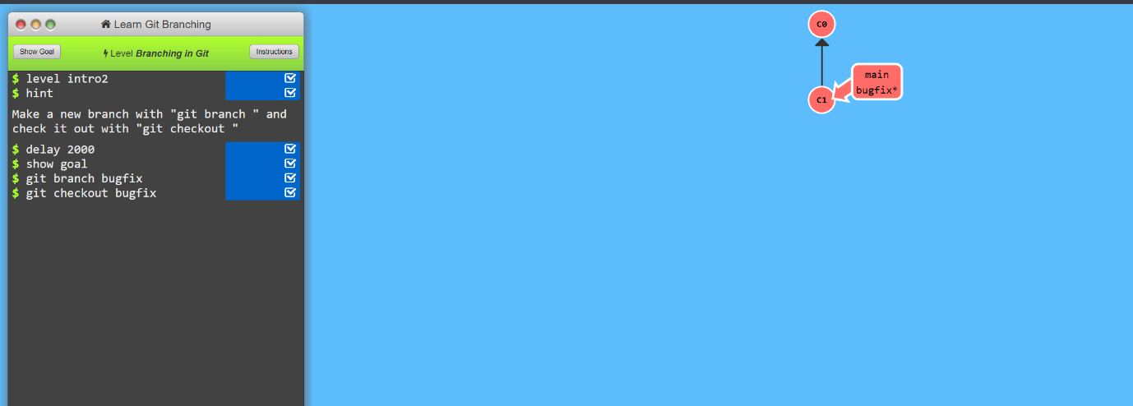

**git merge:**

Combines changes from one branch into another: git merge branch_name. Integrates updates, resolving conflicts if necessary.

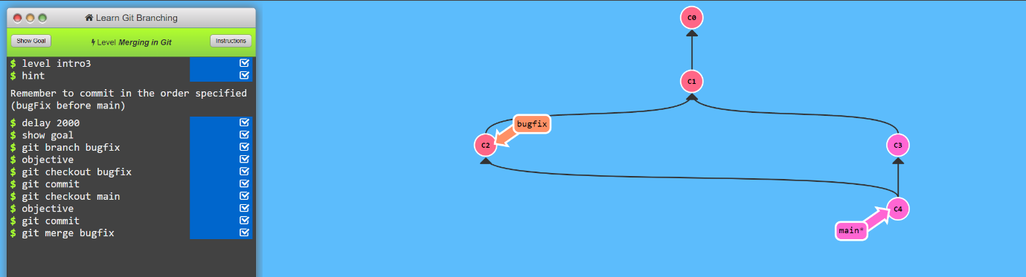

**Git rebase:**

Reapplies commits on top of another base branch: git rebase branch_name. Maintains a clean, linear project history by moving commits.

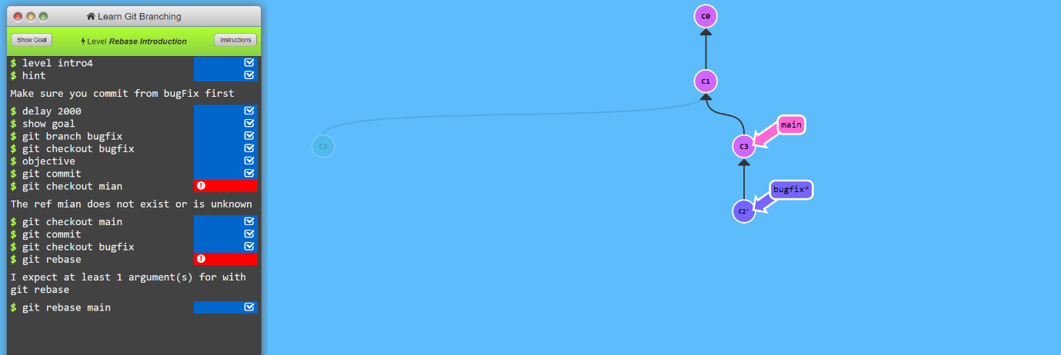

**Artificial Intelligence (AI)**

AI involves creating systems that can perform tasks typically requiring human intelligence, such as reasoning, learning, and problem-solving.

**Machine Learning (ML)**

ML is a subset of AI where algorithms learn from and make predictions or decisions based on data, improving their performance over time without being explicitly programmed.

**Deep Learning**

Deep Learning is a specialized branch of ML that uses multi-layered neural networks to model and understand complex patterns and representations in large datasets.

**Data Science**

Data Science combines domain expertise, programming skills, and knowledge of mathematics and statistics to extract meaningful insights from data and drive decision-making.